# Software Requirements Specification

# PRJ566 – Fall 2024

# PRJ566 – Team No: 4

# Name of Project: Skill Swap Application

# Project Leader:

Diba Makki

**Last updated:**Feb 19, 2025

**Team Members:**

1. Anton Zhuravlev
2. Diba Makki
3. Dylan Dioneda
4. Gia Huy Nguyen
5. Lawrence Wan

# TABLE OF CONTENTS

1. **Introduction/Overview - Document Information**
   1. **Document Authors**
   2. **Revision History**
   3. **Document Conventions**
   4. **Document Purpose**
   5. **Intended Audience**
   6. **Group Agreement**
2. **Project Overview**
   1. **Project Proposal**
   2. **Stakeholders and Users**
   3. **Project Scope**
   4. **Functional Requirements**
   5. **Nonfunctional Requirements**
   6. **System risks**
   7. **Operating Environment**
   8. **UI/UXD Interface Mockups**
3. **Process & Data Modeling**
   1. **UML Modeling: DFDs & Activity Diagrams**
   2. **Use Case Specification** 
      1. **Business Rules**
      2. **System Use Case Diagrams**
      3. **Use Case Description Tables**
4. **Domain Class Diagram**
5. **Database (Select either 5.1 or 5.2)**
   1. **RDBMS Artifacts**
      1. Scripts to create, populate, delete tables
      2. Data Dictionary
   2. **NoSQL Artifacts**
6. **Work breakdown Structure (WBS)**
7. **Milestones & Acceptance Criteria**
8. **Implementation Schedule (Agile/Waterfall)**
9. **Client / Faculty Sign-off**

# 1 - Introduction/Overview - Document Information

## 1.1 Document Authors

Gia Huy Nguyen  
Diba Makki

## 

## 1.2 Revision History

|  |  |
| --- | --- |
| Week 03 | 1. Introduction/Overview  1.1 Document Authors  1.2 Revision History  1.3 Document Conventions 1.4 Document Purpose  1.5 Intended Audience 1.6 Group Agreement 2.1 Project Proposal |
| |  |  | | --- | --- | | Week 04 | Added updates to: 1.3 Document Conventions | | **2.1 Problem Statement:** Identified the need for a centralized skill-sharing platform and its impact. **2.1 Product Vision:** Defined the purpose, target audience, and unique value of SkillSwap. **2.2** **Stakeholders & Users:** Listed key stakeholders and their roles. **2.5 Project Scope:** Outlined included features (e.g., skill matching, scheduling) and exclusions (e.g., payments). **2.6 System Risks:** Highlighted potential risks and mitigation plans. **2.7 Operating Environment:** Described the technical setup, tools, platforms, and security measures. |
| |  |  | | --- | --- | | Week 05 | Completed: 1.4 Document Purpose, 1.5 Intended Audience | | |  |  | | --- | --- | | Week 05 | Completed: 1.4 Document Purpose, 1.5 Intended Audience | |
| |  |  | | --- | --- | | Week 06 | Drafted: 1.6 Group Agreement | | |  |  | | --- | --- | | Week 06 | Drafted: 1.6 Group Agreement | |
| |  |  | | --- | --- | | Week 07 | Updated major deliverable schedules and success factors | | |  |  | | --- | --- | | Week 07 | Updated major deliverable schedules and success factors | |
| |  |  | | --- | --- | | Week 08 | Reviewed and finalized constraints, assumptions, and risks | | |  |  | | --- | --- | | Week 08 | Reviewed and finalized constraints, assumptions, and risks | |
| |  |  | | --- | --- | | Week 09 | Reviewed full document for alignment with objectives | | |  |  | | --- | --- | | Week 09 | Reviewed full document for alignment with objectives | |
| |  |  | | --- | --- | | Week 10 | Conducted a team-wide review and added final suggestions | | |  |  | | --- | --- | | Week 10 | Conducted a team-wide review and added final suggestions | |
| |  |  | | --- | --- | | Week 11 | Finalized content for submission | | |  |  | | --- | --- | | Week 11 | Finalized content for submission | |
| |  |  | | --- | --- | | Final | Document completed and submitted | | |  |  | | --- | --- | | Final | Document completed and submitted | |

## 1.3 Document Conventions

For example:

Any text in red indicates an exception or error.

Any text in blue is in-progress.

Any text highlighted in yellow is an important point.

Any text in green was recently added.

Any text *italicized* represents definitions.

Any text with ~~strike-through~~ is deleted.

## 1.4 Document Purpose

This Business Case Study document outlines the rationale, objectives and strategic plan for the Skill Swap Application, a platform designed to enable skill sharing without monetary exchange, It aims to provide a clear vision of the project, guide decision-making by analyzing market opportunities and risks, define Key requirements, and secure stakeholder buy-in. Additionally, it establishes a roadmap with detailed timeline and budget to ensure the successful development, launch, and post-launch improvement of the app. This document is intended for stakeholders, including investors, development teams, and senior management, to align efforts and ensure the project’s success.

## 1.5 Intended Audience

This document is intended for:

1. **Investors**: Individuals or organizations providing funding for the SkillSwap project. They need to understand the business case, financial projections, and potential return on investment.
2. **Senior Management**: Executives and decision-makers within the organization who will approve the project, allocate resources, and oversee its progress.
3. **Development Team**: Engineers, designers, and developers responsible for building the SkillSwap app. They require detailed technical requirements, timelines, and deliverables.
4. **Marketing Team**: Professionals tasked with promoting the app and driving user adoption. They need insights into the target market, unique selling points, and launch strategy.
5. **Legal and Compliance Teams**: Experts ensuring the app adheres to data privacy, security standards, and other regulatory requirements.
6. **Project Managers**: Individuals overseeing the project’s execution, ensuring it stays on track, within budget, and meets deadlines.
7. **End Users (Indirect Audience)**: While not directly reading the document, the needs and expectations of potential SkillSwap users are central to the app’s design and functionality.
8. **Partners and Collaborators**: External organizations or individuals who may collaborate on the project, such as vendors, consultants, or community groups.
9. **Stakeholders**: Any other internal or external parties with an interest in the project’s success, such as advisors, board members, or industry experts.

## 1.6 Group Agreement

**TEAM AGREEMENT**

**Team #: Group 4**

**Project Title: SkillSwap Application**

**Project Time Frame: 9 months**

**Team Members:**

**Diba Makki ( Project Leader )** : Oversees the project and ensures smooth execution.  
**Dylan Dioneda ( UI/UX Designer )** : Designs the app’s interface and user experience.  
**Gia Huy Nguyen ( Backend Developer )** :  Builds the server-side infrastructure and APIs.  
**Lawrence Wan ( Frontend Developer )** : Implements the client-side interface and ensures responsiveness.  
**Anton Zhuravlev (Quality Assurance(QA))** :  Tests the app for bugs, performance, and security

**Team Leadership:**

**Diba Makki**

**Team Functions:**

* *We will share information through MS Teams, OneDrive, GitHub ,email, and meetings.*
* *Conduct weekly meetings to track progress and resolve issues.*
* *Ensure timely communication and task delegation to meet deadlines.*

**Team Meetings:**

* Frequency: Weekly
* Medium: Virtual (MS Teams or Zoom)

**Team Problems:**

* All issues will be discussed during weekly meetings.
* Escalation of unresolved issues to the project lead.

**Team Commitment**

**The undersigned members agree to work together on the project until the end of the PRJ666 next Semester. They recognize that as a team and individually they are responsible for the quality of all deliverables.**

**Name Date**

|  |  |
| --- | --- |
| Gia Huy Nguyen | 2025 01-26 |
| Anton Zhuravlev | 2025 01-26 |
| Diba Makki | 2025 01-26 |
| Dylan Dioneda | 2025 01-26 |
| Lawrence Wan | 2025 01-26 |

ShapeShapeShapeShapeShapeShapeShapeShape

# 2 - Project Overview

## 2.1 Project Proposal

Project Background

In today’s fast-paced and interconnected world, the demand for skill-sharing and collaborative learning has grown significantly, yet there is no centralized, efficient, and trustworthy platform to facilitate skill exchanges without monetary transactions. Currently, skill-sharing happens informally through word-of-mouth, social media, or local community boards, leading to disorganization, trust issues, and scheduling challenges. SkillSwap aims to address this gap by creating a user-friendly app that connects individuals to exchange skills in a structured, reliable, and community-driven manner. The platform will leverage advancements in technology to offer features like skill verification, secure authentication, and scheduling tools, ensuring a seamless and trustworthy experience. With the rise of collaborative economies and the increased adoption of digital platforms for learning and connection—accelerated by the COVID-19 pandemic—SkillSwap is well-positioned to tap into this untapped market and become a leading solution in the skill-sharing space.

**Problem Statement**

|  |  |
| --- | --- |
| The Problem of: | Lack of a centralized, efficient, and trustworthy platform for skill-sharing without monetary exchange. |
| Affects: | Individuals seeking to learn or share skills, communities, and organizations that could benefit from collaborative learning. |
| The impact of which is: | Disorganized skill exchanges, lack of trust and verification, scheduling conflicts, and unmet expectations, leading to inefficiency and frustration. |
| A successful solution would: | Provide a user-friendly, secure, and community-driven platform that enables seamless skill-sharing, ensures skill verification, and facilitates reliable matchmaking and scheduling |

**Product Vision**

|  |  |
| --- | --- |
| For | Individuals and communities seeking to share and learn skills without monetary exchange. |
| Who | Wants a reliable, efficient, and trustworthy platform for skill-sharing. |
| The Product Name | SkillSwap |
| That | Connects users to exchange skills seamlessly, offering features like skill verification, secure authentication, and scheduling tools. |
| Unlike | Informal skill-sharing methods (e.g., social media, word-of-mouth) that lack structure, trust, and reliability. |
| Our product | Provides a centralized, user-friendly platform that fosters collaboration, ensures trust, and makes skill-sharing accessible to everyone. |

## 2.2 Stakeholders and Users

|  |  |
| --- | --- |
| Stakeholder Name/Identifier | Category |
| CEO (Chief Executive Officer) | Administration, Sponsor |
| Primary Users | SkillSwap App Users (End Users) |
| Investors | Angel Investors, Venture Capitalists |
| Development Team | Developers, Designers, QA Testers |
| Marketing Team | Marketing Specialist, Social Media Managers |
| Management | Project Sponsors |
| Legal and Compliance Team | Legal Advisor, Compliance Officers |

## 2.3 Functional Requirements

Functional Requirements for the project would be to have User Management so that users can log in with accounts that they make using their email and usernames and passwords they think up and any other relevant data like, real name, date of birth, this would also require secure login and authentication. There is also talents that would need to be included as well, a panel that users can go to and edit to show their best foot forward, like some sort of resume that people can scroll through and see when they search for a specific job.

There would also be requirements for better security so users can use the app with total safety, when they are logging in, to ensure no one steals their account, when they talk to other users so that their chats cant be seen by the public eye, but we would also need moderation, so that nothing illegal or morally wrong is happening in the app

## 2.4 Nonfunctional Requirements

Nonfunctional Requirements for the project would include things along the lines of, performance and scalability, end user experience, cross platform compatibility as well as reliability of the program with things like maintenance and program upkeep as we are still in the planning stages of the program those tasks which would provide quality of life to the users are not yet needed

## 2.5 Project Scope

The SkillSwap project aims to develop and launch a user-friendly, secure platform that enables individuals to exchange skills without monetary transactions. The app will include key features such as mobile and web compatibility, secure user authentication, skill verification, skill matching, scheduling tools, and community-building features like forums and chat functionality. Additionally, an admin dashboard will be developed for platform management, and comprehensive testing will ensure a bug-free and secure application. The project will culminate in a coordinated app launch supported by a marketing campaign to drive user adoption. The timeline for development is 9 months, with an additional 3 months allocated for post-launch improvements, and the total budget is set at $500,000, covering development, marketing, and contingency expenses.

Certain features and functionalities are explicitly out of scope for this project. These include monetary transactions, advanced AI-driven features, offline functionality, and global expansion. The initial launch will focus on a specific region or market, with scalability in mind for future growth. The project assumes user willingness to adopt the platform, the development team’s ability to deliver within budget and timeline, and user trust in the platform’s verification and matching systems. Key risks include low user adoption, security vulnerabilities, and potential delays, while constraints include the limited budget, strict timeline, and compliance with data privacy regulations. By defining these boundaries, the project ensures a clear focus on delivering a secure, efficient, and community-driven skill-sharing platform.

## 2.6 System Risks

|  |  |
| --- | --- |
| **Risk** | **Response** |
| Data privacy and security vulnerabilities could expose user information. | Implement robust encryption, comply with data privacy regulations, and conduct regular security audits. |
| Delays in backend development could impact the overall project timeline. | Allocate additional resources to backend development and set up frequent progress check-ins to ensure milestones are met. |
| Low user adoption due to a lack of awareness or trust in the platform. | Launch a targeted marketing campaign, offer incentives for early adopters, and implement a user feedback loop to build trust and improve the platform. |
| Integration issues between the mobile and web versions of the app. | Use a unified development framework and conduct cross-platform testing to ensure seamless integration. |
| Skill verification system may be exploited or abused by users. | Implement a multi-step verification process, including user reviews and manual checks for high-risk skills. |
| Scalability challenges as the user base grows. | Design the app with scalability in mind, using cloud-based infrastructure and load testing to handle increased traffic. |

## 2.7 Operating Environment SkillSwap will be built using **React Native** for mobile apps (iOS and Android) and **HTML/CSS** for the web. The backend will use **Node.js** with a **MongoDB** database, hosted on **AWS** or **Google Cloud**. The app will work on **iOS 14+**, **Android 10+**, and modern browsers like Chrome and Safari. It will include **secure login** (OAuth 2.0 and JWT), **data encryption**, and follow **GDPR/CCPA** rules. Testing will ensure the app works well and is secure. After launch, we’ll use tools like **New Relic** to monitor performance and fix issues quickly.

## 2.8 UI/UXD Interface Mock-ups

URL: https://wireframe.cc/FWoQuI

# Process and Data Modeling

## **3.1 UML/DFD Modeling and Data Modeling**

## Activity Diagram

## Data Flow Diagram

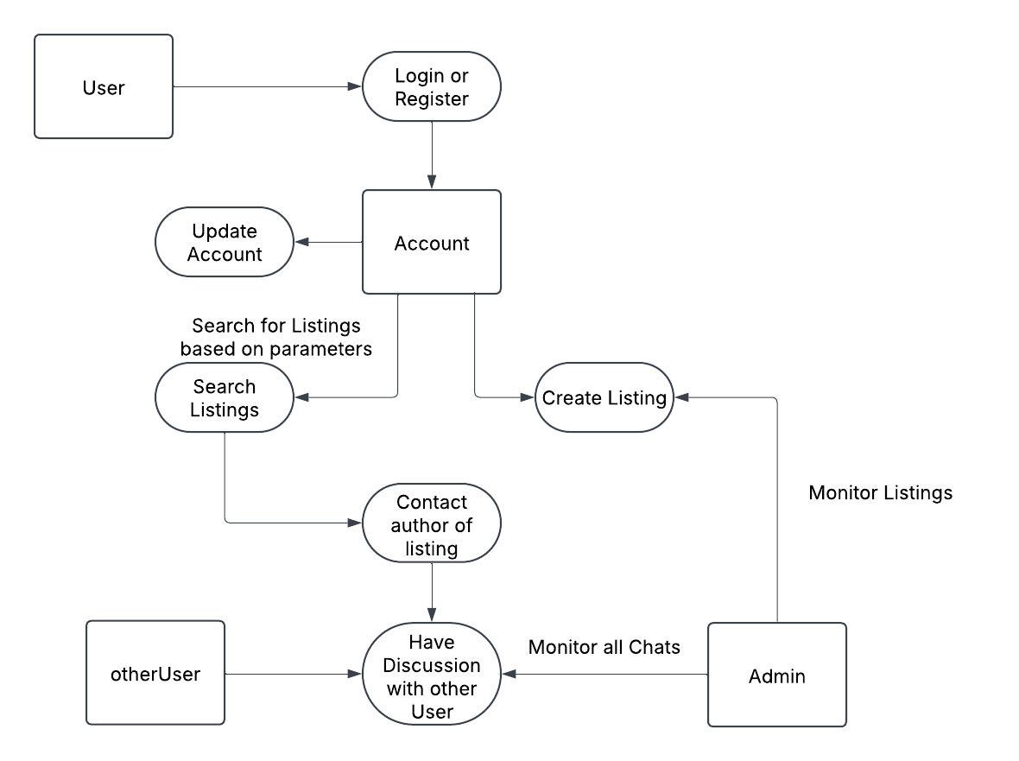

## **3.2 Business Rules**

|  |  |  |
| --- | --- | --- |
| Business Rule Number | Business Rule Description | Related UC |
| BR01 | User must provide a username, email and password to register for the app. | UC01 |
| BR02 | Post length can be no longer than 300 characters | UC02 |
|  |  |  |
|  |  |  |
|  |  |  |
|  |  |  |
|  |  |  |
|  |  |  |
|  |  |  |
|  |  |  |
|  |  |  |
|  |  |  |
|  |  |  |
|  |  |  |
|  |  |  |
|  |  |  |
|  |  |  |

## **3.3 Use Case Specifications with corresponding interface mockups:**

**Each use case needs to have the following:**

1- **Business Rules.**

**2- System Use Case Diagrams.**

**3- Use Case Descriptions.**

**4- Corresponding Mockups**

# Domain Class Diagram

# Database

# Work Breakdown Structure (WBS)

## 

## Work Breakdown Structure

Sample WBS:

# Milestones and Acceptance Criteria

* 1. Milestone one

Definition

Acceptance Criteria

* …
* ….
* ….
  1. Milestone Two
  2. Milestone Three
  3. ..
  4. …
  5. …
  6. ..
  7. ..
  8. ...etc.

# Implementation Schedule

Implementation Schedule using MS Project (Waterfall)

OR

Product Backlog (Agile-Scrum)

# Client / Faculty Sign-off

**Date: ______________________**

X .

Name of Client/Rep/Professor